# Install VPN Client

1. Run the installer attached above.



1. Once VPN client it is installed open the application.

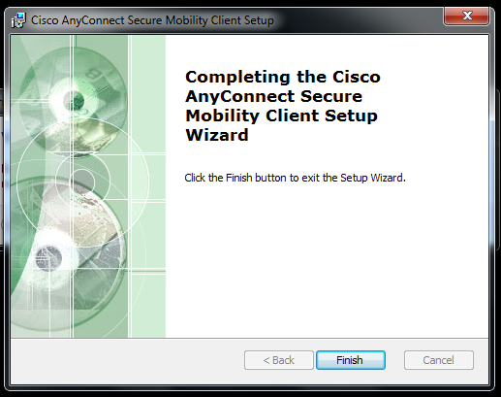

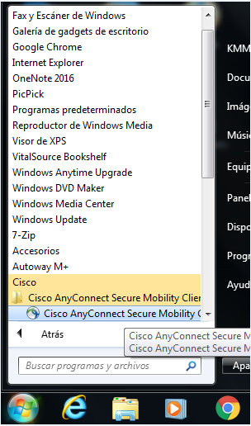

1. Type the following IP to start the connection.

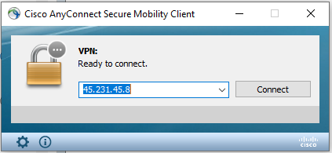

1. System may pop up a red warning, select “change settings” and uncheck the option “block connection to untrusted servers”

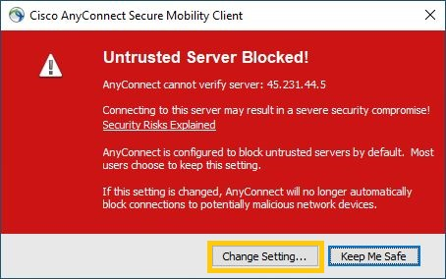

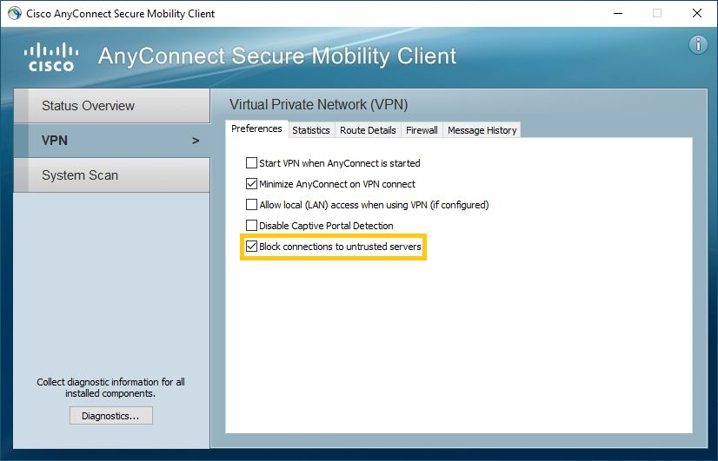

1. Type your VPN credentials provided by your Security Administrator.

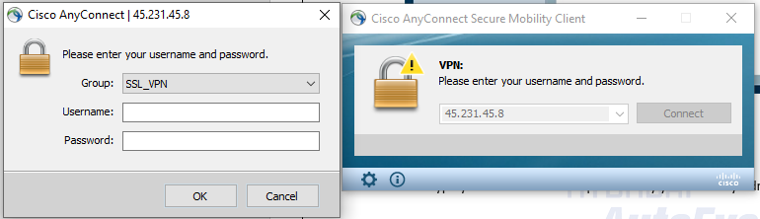

1. Once you are connected. Open Remote Desktop Connection and type your IP address

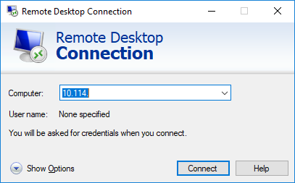

1. System will ask for credentials, it’s important to put the following way:

Example:

