# Install VPN Client

1. Click on the below link and enter your credential on the website

<https://189.206.189.98/global-protect/login.esp>

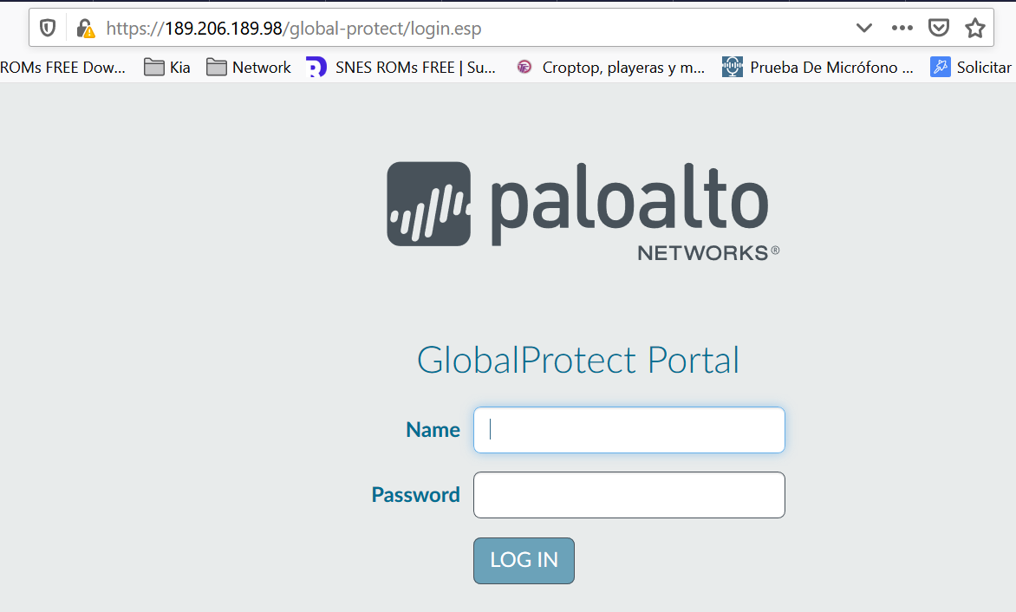

1. Download the client according to the OS on your PC and install

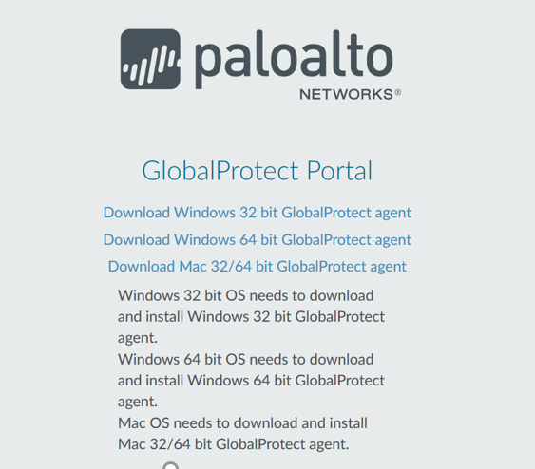

1. Type the following IP to start the connection.

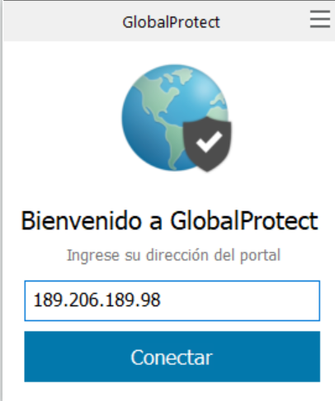

1. Enter login credentials

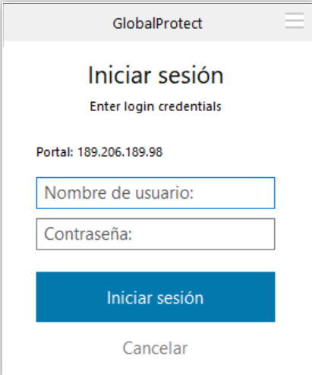

1. Click Continue on the certificate warning.

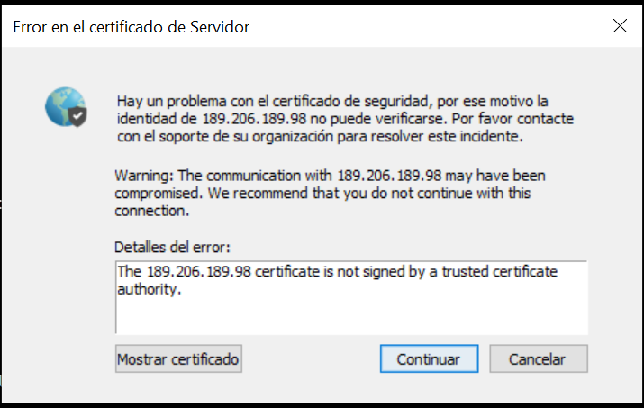

1. Once you are connected. Open Remote Desktop Connection and type your IP address

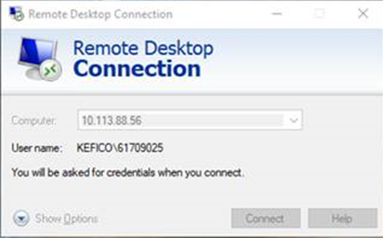

1. System will ask for credentials, it’s important to put the following way:

Example:

