# **VPN Connection Manual for MAC clients**

1. **First of all make sure you to open the manual in edit mode**

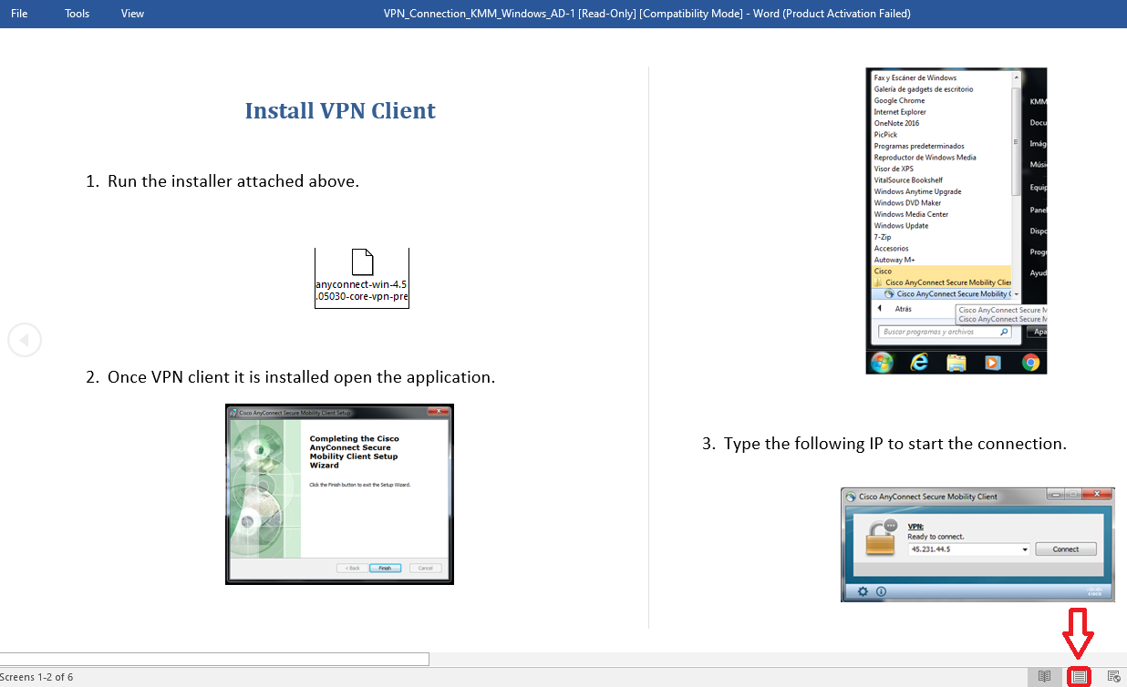

1. **First of all go to Settings -> Security and Privacy and enable the option to “make changes on the Mac” and “App Store and identified developers” from the menu Allow apps downloaded form:**

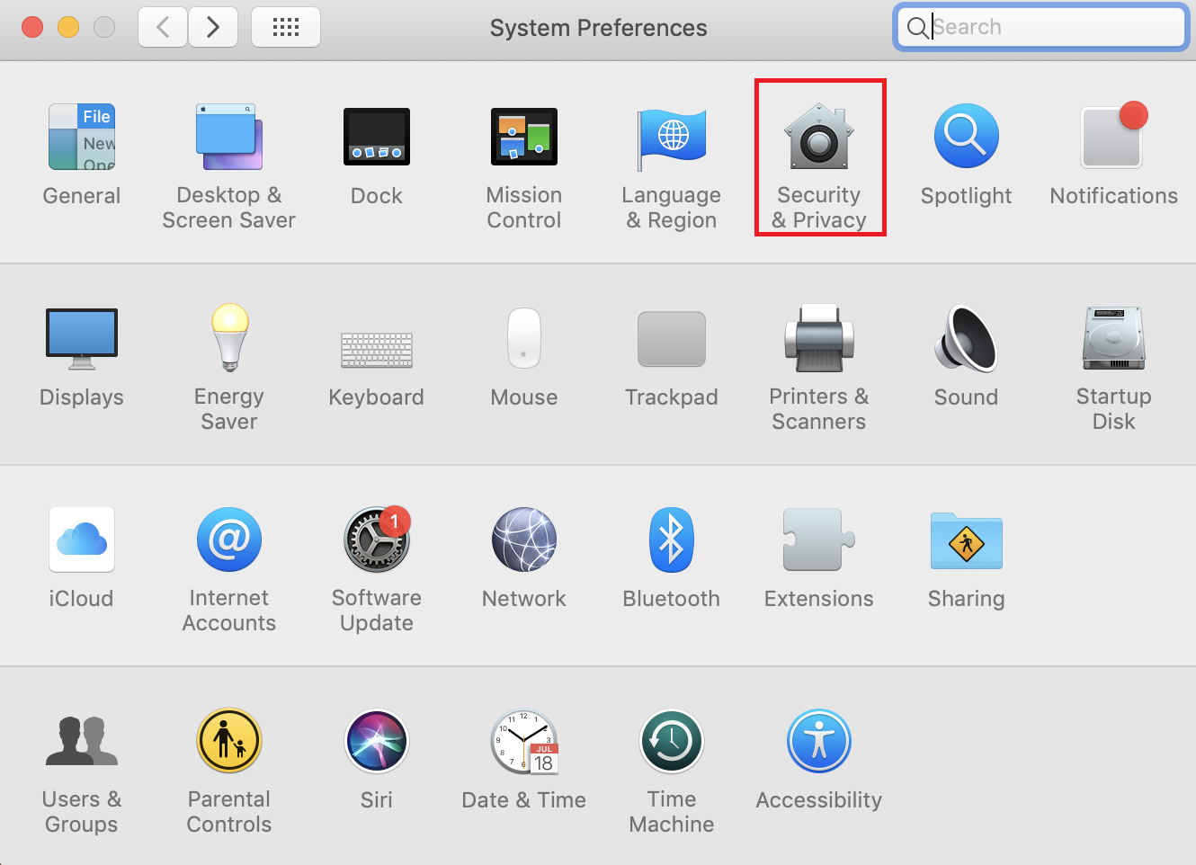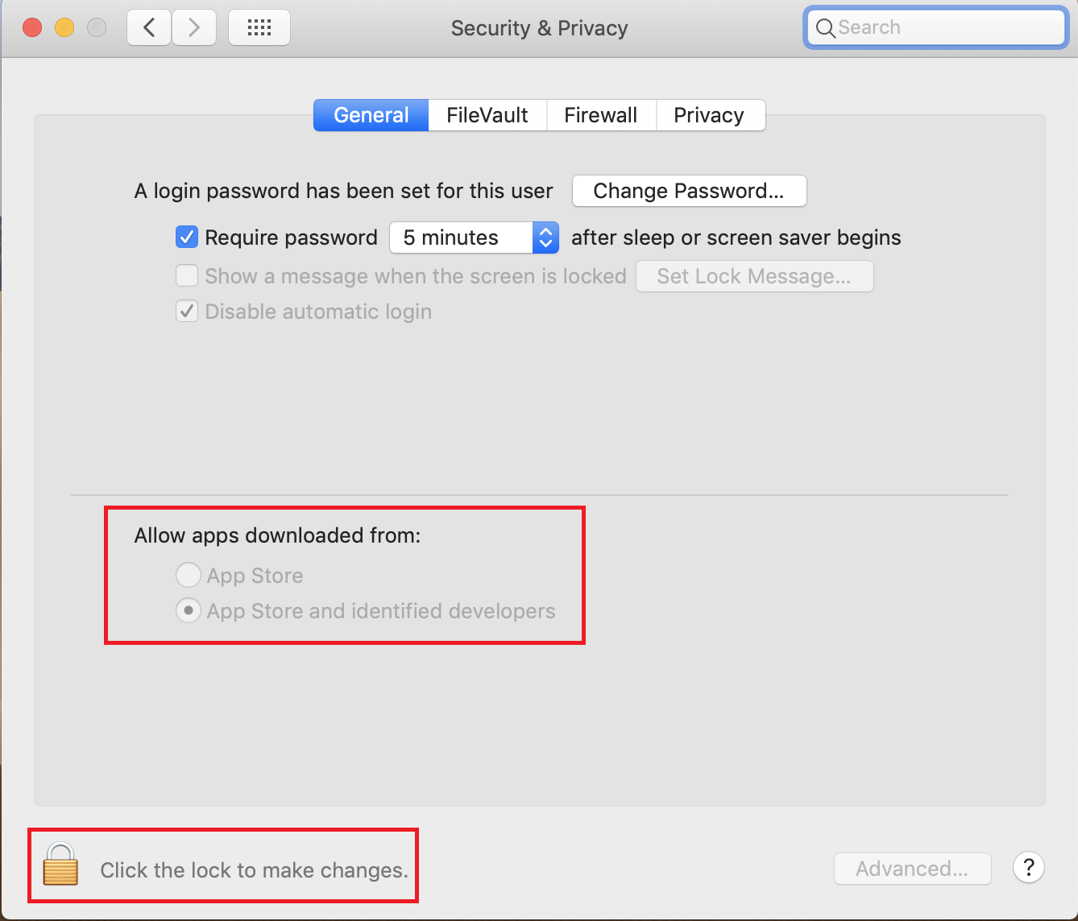

1. **Once you have enable the app store and identified developer’s option, proceed to install the VPN client, double click on the icon below and run it.**

* **Please don’t install this attached file in the KMM office PC.**

**If you install the VPN software to your office PC, the PC will not be worked.**



1. **Once you have opened the VPN client type the KMM’s public IP as shown in the image and click connect, and alert will appear and select the option “Change Settings”**

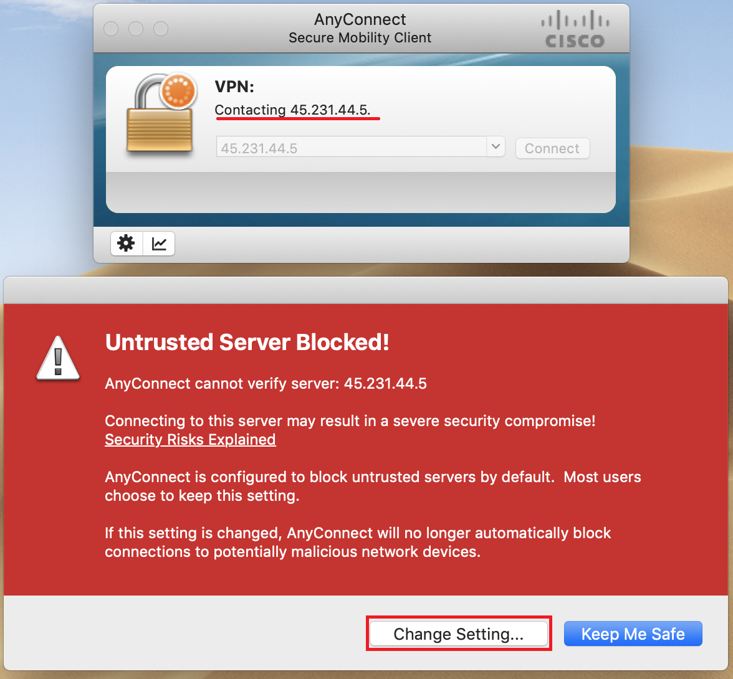

1. **Disable the option “Block connections to untrusted servers” and close the window.**

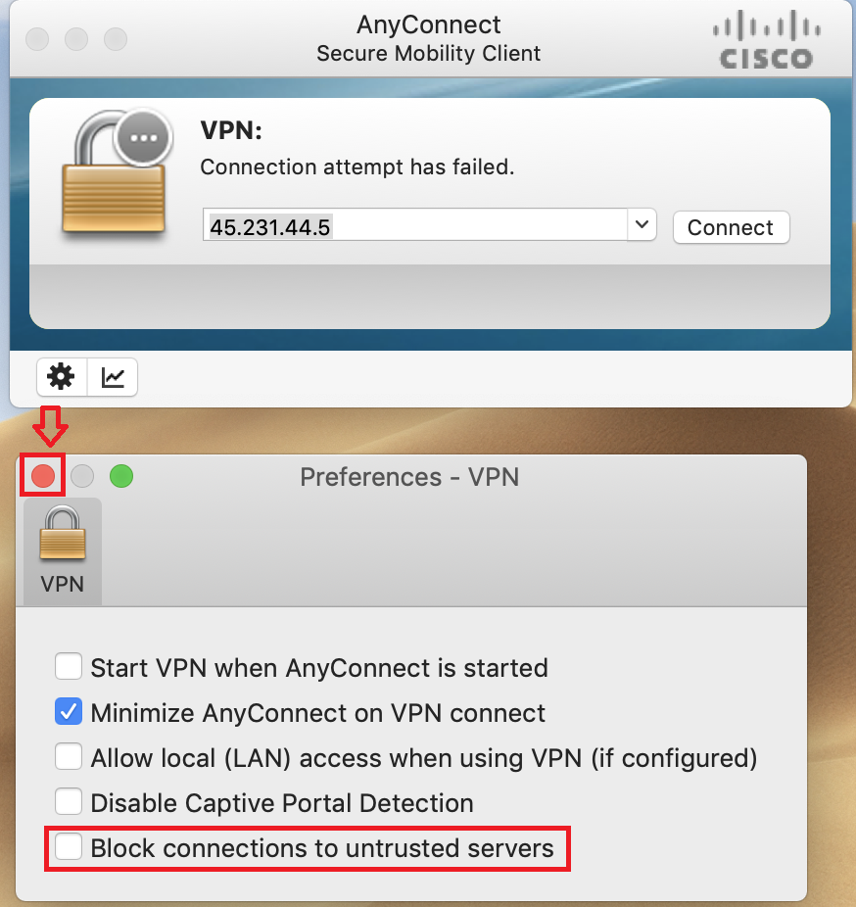

1. **Click “Connect” and select the option “Connect Anyway”** 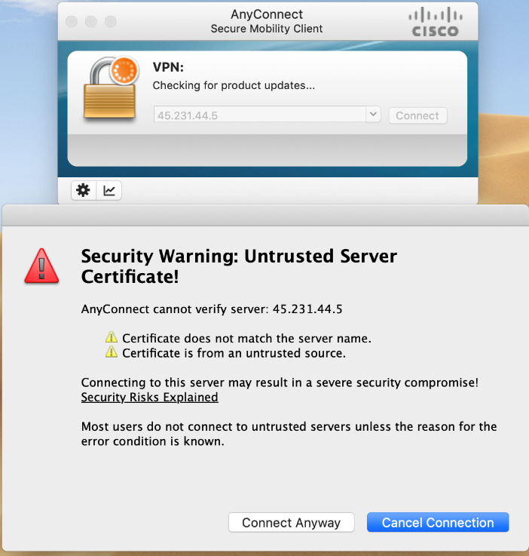
2. **Select the Group_Covid19 and use your Windows Credentials(the ones used to unlock your computer PC) without KMAM**

**Example for KMM users:**

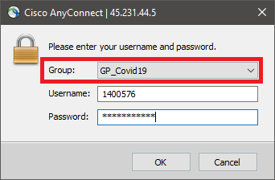

K301052100100

1. **Now you are connected to the KMM Network through VPN, next step is start a Remote Desktop Connection session, if you don’t have it, you can get it from app store, I use the below one: “Microsoft Remote Desktop”**

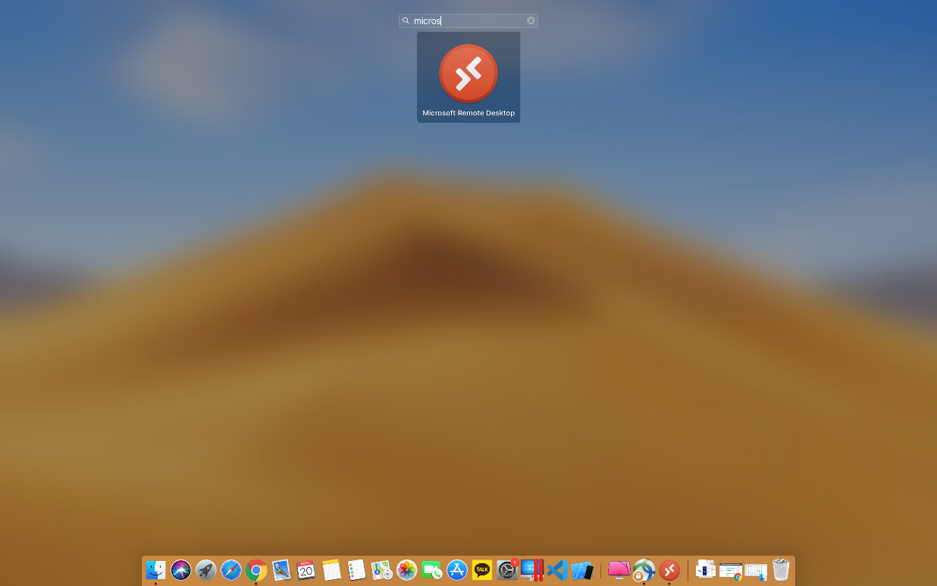

1. **Click on “Add PC” and input your Computer IP and click Add.**

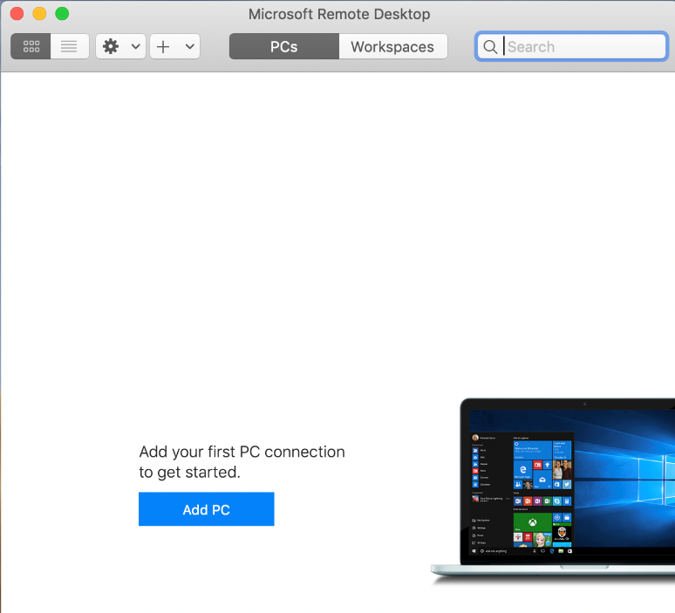

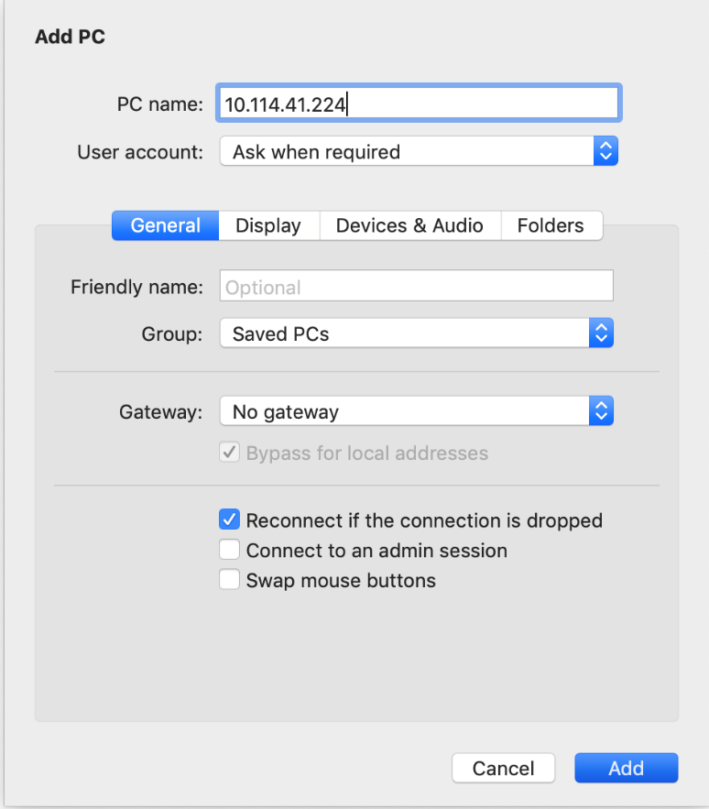

1. **Double click on the computer icon with your corresponding computer IP.**

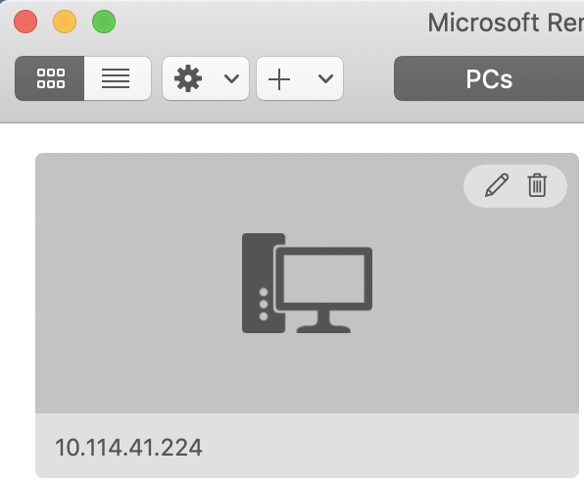

1. **Now input your Windows credentials,**

**Example: starting with “KMAM\K301052102321 and Password: (Windows password) as shown below:**

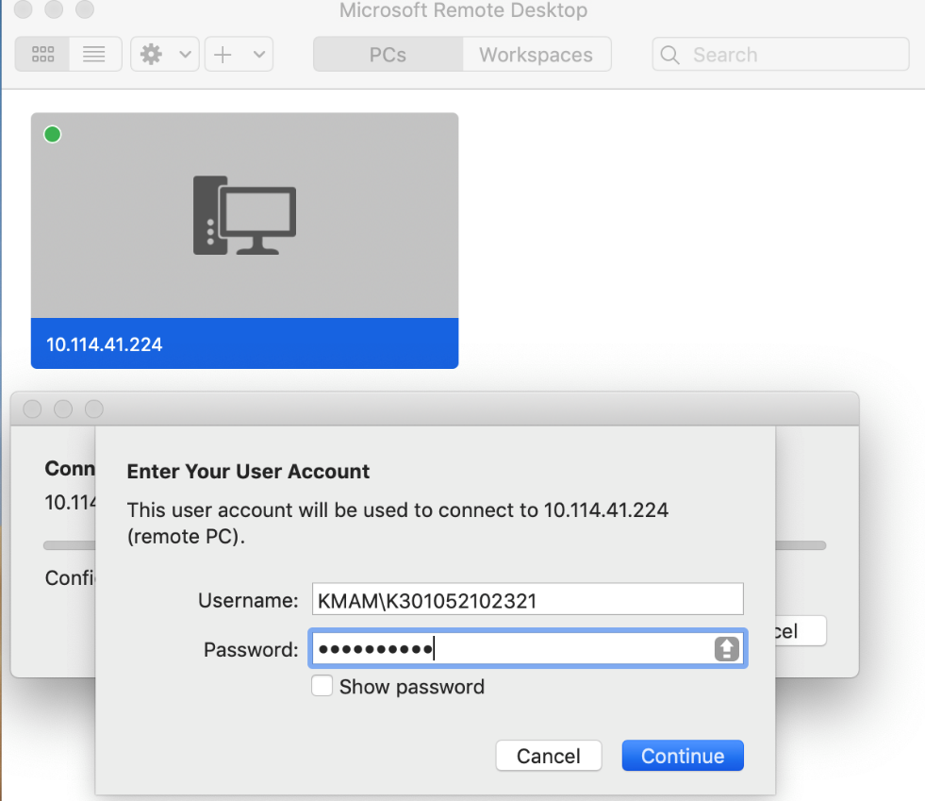

1. **Select continue and the remote connection will be established.**

