# Install VPN Client

1. **First of all make sure you to open the manual in edit mode**

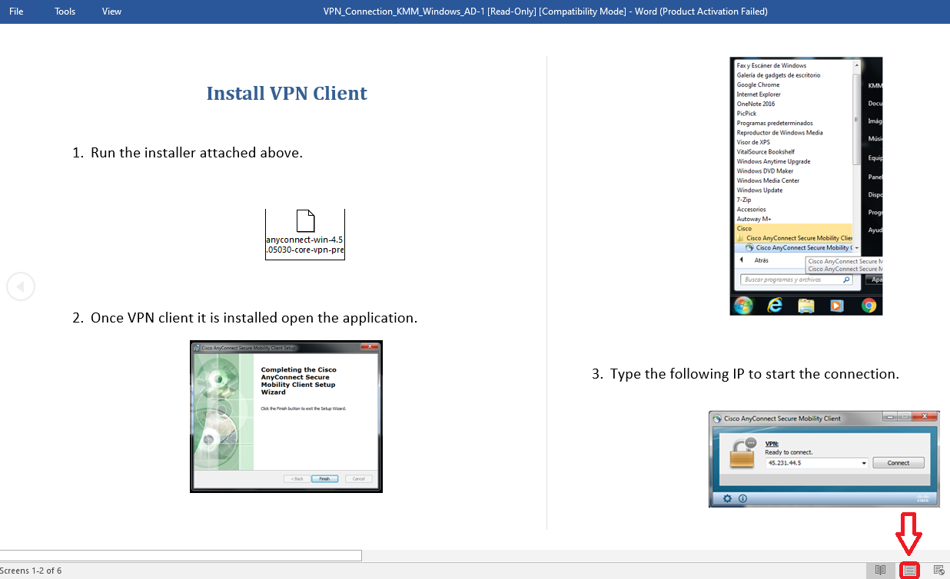

1. **Run the installer attached above. Save/Drag it first on you Desktop or Documents folder.**

* **Please don’t install this attached file in the KMM office PC.**

**If you install the VPN software to your office PC, the PC will not be worked.**



1. **Open the VPN application after the VPN client software installation.**

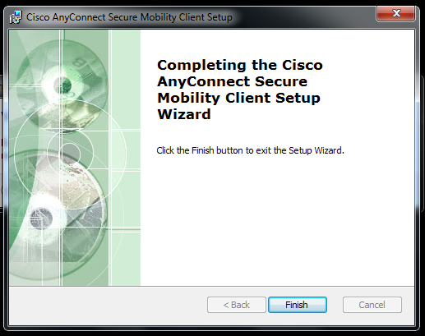

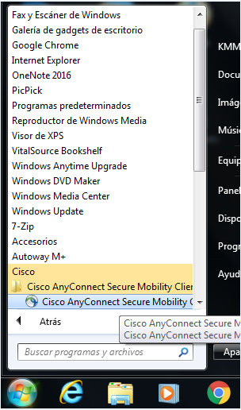

1. **Input the IP in the picture to connect VPN network. (45.231.44.5 or vpn.kia-mexico.com)**

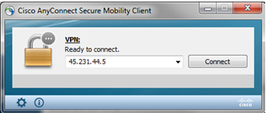

1. **System may pop up the red warning,**

**Select “change settings” and uncheck the option “block connection to untrusted servers”**

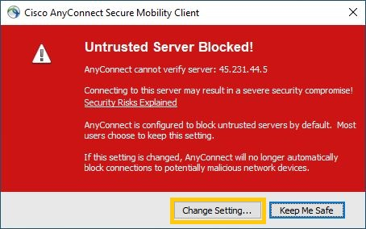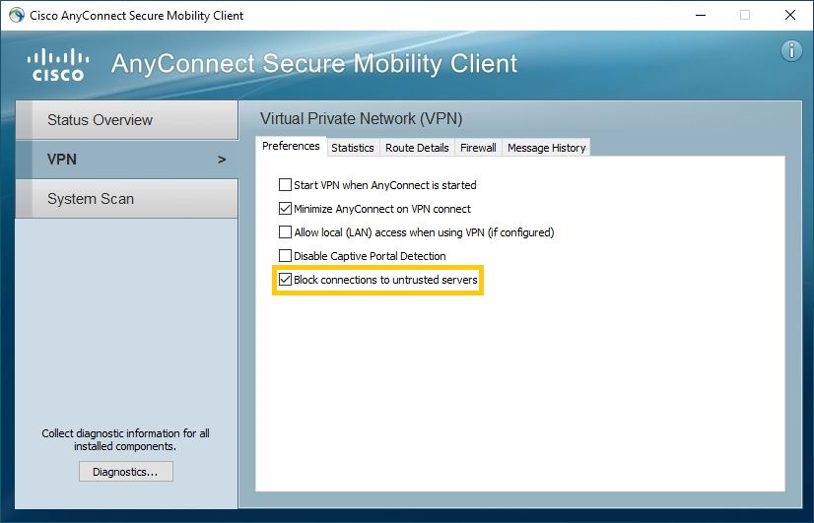

1. **Select Group ‘’1.KMX RDP VPN’’ and input your windows account (13 characters)**

**(EX. ID : K301052100100, PWD : Windows password)**

* **If log in is not possible, please try to input your ID like this below.**

**(kmam\K301052100100)**

Example:

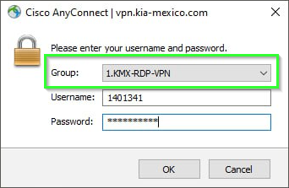

After entering credentials, on your cell phone you will receive a PUSH from CISCO DUO, which must be approved to finish the VPN connection process.

**Important note**: You must be previously registered in Cisco Duo. If not, please contact KMX IT department to request registration.

1. **Open ‘Remote Desktop Connection’ and input your office PC IP address**

**after connecting to the VPN.**

* Windows –> run –> mstsc (Remote Desktop connection shortcut)

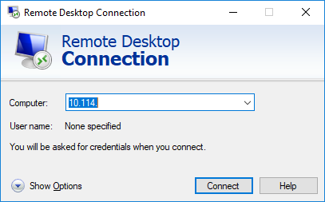

1. **System will ask you the ID and password.**

**Please input the user information following the way below:**

ID: KMAM\(your 13 characters ID) - \ : Backslash

PSW: (your windows password)

Example:

