# Install VPN Client

1. Run the installer attached above.



1. Once VPN client it is installed open the application
   1. Check the box and click on “ I Accept “ button

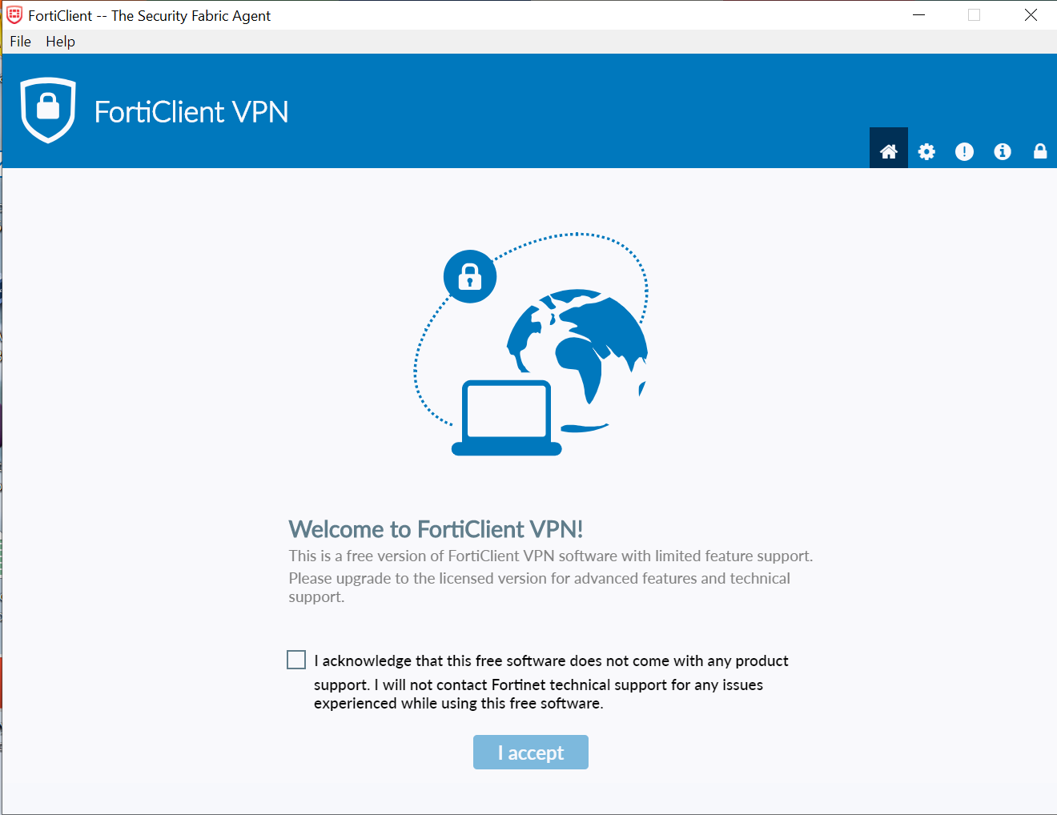

1. Click on Configure VPN

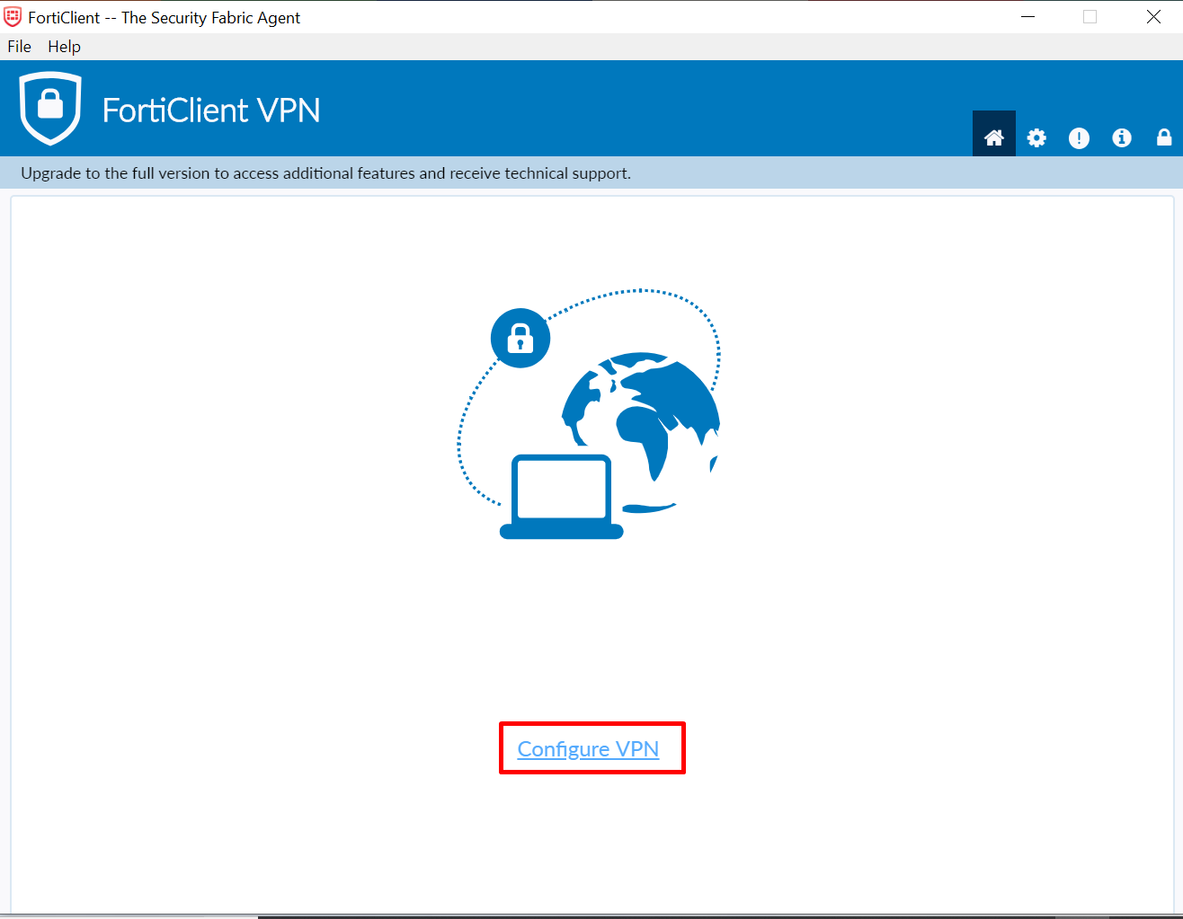

1. Select SSL-VPN and configure the below information
   1. Connection Name: type a name for your connection (e.g home_office)
   2. Remote Gateway: 200.76.16.225
   3. Check the box “Customize port” and type 8888 on the field box
   4. Check the box “Do not Wean Invalid Server Certificate”
   5. Live everything else as it is
   6. Click “ Save “

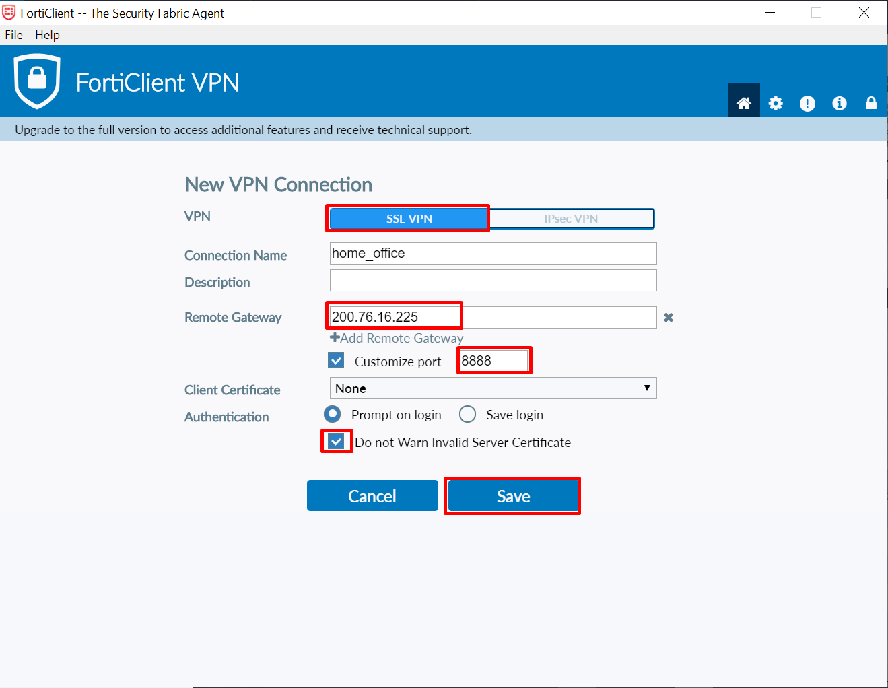

1. Selec the VPN Name from the dropdown list and type your VPN credentials provided by your Security Administrator and click “ Connect “

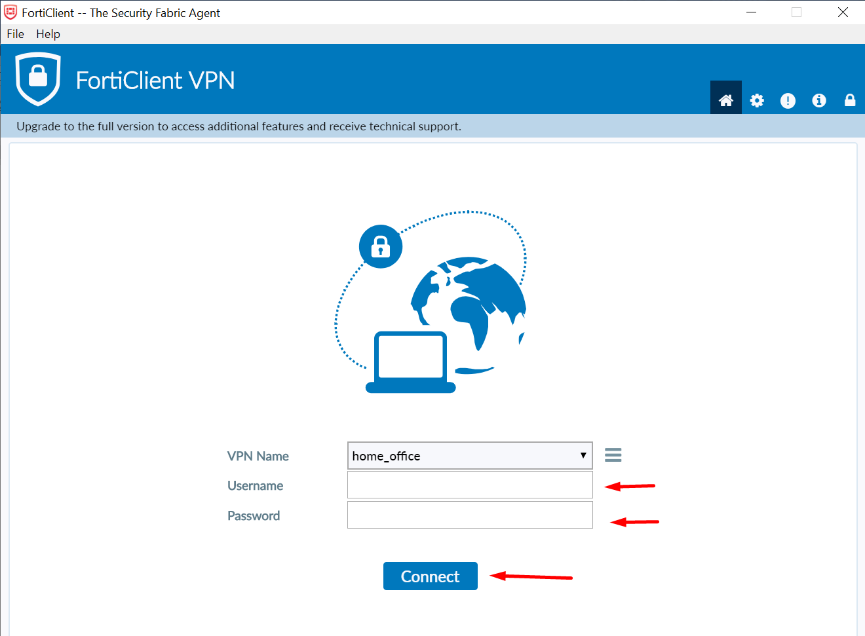

1. Once you are connected. Open Remote Desktop Connection and type your IP address

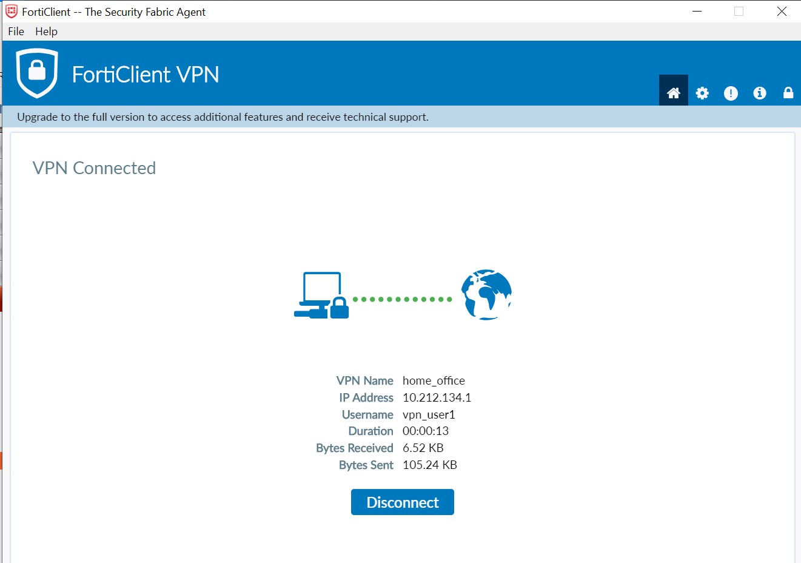

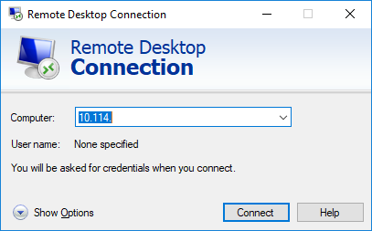

1. System will ask for credentials, it’s important to put the following way:

Example:

