Install VPN Client

- Run the installer attached above.

- Once VPN client it is installed open the application.
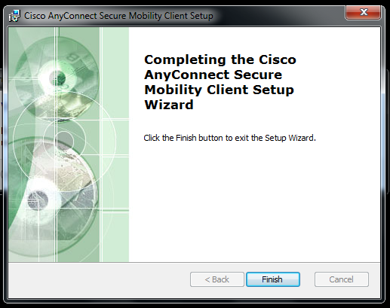
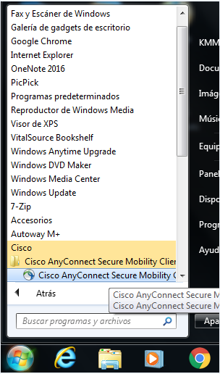

- Type the following IP to start the connection.

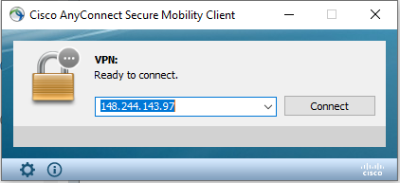

- System may pop up a red warning, select “change settings” and uncheck the option “block connection to untrusted servers”
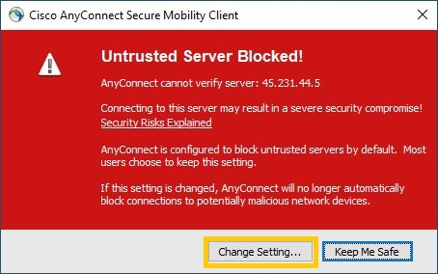
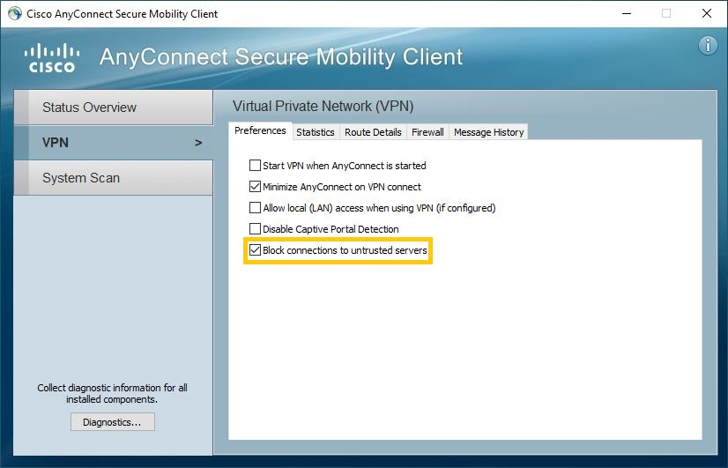

- Type your VPN credentials provided by your Security Administrator.

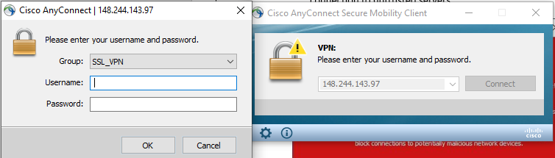

- Once you are connected. Open Remote Desktop Connection and type your IP address

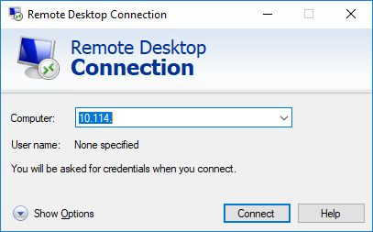

- System will ask for credentials, it’s important to put the following way:

Example:

